1. Introducing ecological proteomics

Over the last decade we have seen a step change in our ability to investigate the molecular bases of biological adaptation and evolution. Rapidly progressing ‘omics’ technologies now allow researchers to characterise complete sets of biological molecules in non-model organisms (Wang, Gerstein & Snyder 2009; Ekblom & Galindo 2010; Armengaud *et al.* 2014). Extent of protein expression determines an organism’s capacity to perform biochemical functions where the rate at which work is done is a function of the amount of protein doing the work (ref – Michaelis & Menten?). In photosynthesis, for example, light energy captured by light harvesting proteins is used to catalyse carbon uptake from the atmosphere by enzymatic carboxylation. The rate at which plants are able to perform this process is a function of the abundance of photosynthetic proteins in their leaves (Evans 1989?). As such, quantifying protein amounts using proteomics methods provides direct information about how organisms are adapted to their environment (Diz & Calvete 2016).

Proteomics is becoming a useful tool in ecological and evolutionary research because genomic resources are increasingly available for non-model organisms. Comparative data on the abundances of proteins or groups of proteins which perform key biochemical functions measured under different environmental conditions could provide mechanistically explicit insight into organism-environment relationships. Comparative ecological proteomics would require rapid, scalable methods for absolute quantification of protein abundances in wild organisms. To date however, absolute quantification of plant proteins has proved to be challenging: proteins are difficult to extract from plant tissues and the required data-dependent mass spectrometric methods remain novel (refs from Steve).

1. A continental-scale field study of the molecular composition of leaves

We have developed proteomics methods which allow comprehensive extraction of leaf proteins and absolute quantification of the top 2000-3000 most abundant proteins. This allows us to compare protein abundances between samples, which has been demonstrated in model organisms under controlled environments (need refs from Steve) but not in a large-scale, fully replicated ecological study in wild plants.

Using this new technology, we have conducted (a/the first) continent-scale ecological proteomics experiment to characterise the influence of biogeographic and environmental controls on leaf protein expression. We analysed 320 eucalypt leaves across 32 species sampled from Tasmania, New South Wales, and Queensland, spanning large gradients of mean annual precipitation and temperature (200-3200 mm and 5-27 °C) (Fig. 1).

1. How do leaves construct their photosynthetic apparatus in different environments?

Here we do not investigate the very many possible relationships between abundances of different protein functional categories and environmental variables. Rather, we have concentrated this initial analysis on photosynthesis, as it represents one of the most important and abundant set of biochemical reactions in the biosphere (Blankenship & Hartman 1998; Raven 2013). The 500 most abundant proteins account for >90% total leaf protein by weight and the majority of these are involved in photosynthesis and photorespiration (see Fig. X in *Methods*).

Much of what is known about variation in photosynthetic capacity in wild plants is derived from measurements of leaf nitrogen content (Wright et al 2004, Hikosaka 2010), on the basis that photosynthetic proteins comprise the largest pool of nitrogen in leaves (REF). A more nuanced understanding of how the photosynthetic apparatus is optimised under varying environmental conditions requires quantifying differential investment in its subcomponents (Niinemets 2007).

Mathematical models of photosynthesis describe two important processes in photosynthetic carbon assimilation: carboxylation of ribulose-1,6-bisphosphate (RuBP) by the enzyme Rubisco, and regeneration of RuBP using energetic products derived from the light reactions of photosynthesis (Farquhar, von Caemmerer & Berry 1980; Farquhar, von Caemmerer S & Berry 2001). Theoretically, either of these processes can limit the rate of photosynthesis, depending on whether leaves are light or CO2 limited (REF). According to the co-ordination hypothesis of C3 photosynthetic acclimation, proportional allocation of protein resources to the light capturing photosystem complexes and carbon fixing Calvin cycle enzymes should be optimised such that carboxylation and regeneration of RuBP are co-limiting in leaves under average daytime conditions (Haxeltine & Prentice 1996; Chen *et al.* 2009; Maire *et al.* 2012). Previously, leaf chlorophyll content expressed in nitrogen equivalents has been used as a proxy for investment in light capturing machinery (Niinemets & Tenhunen 1997), while Rubisco abundance has typically been estimated using gas exchange methods to estimate rates of carboxylation (ref). Our leaf protein abundance dataset provides the opportunity to directly test hypotheses about molecular adaptation of the photosynthetic apparatus to environmental conditions.

Following co-ordination theory, we derived a set of predictions about differential investment in light capture and carbon assimilation along gradients of temperature, precipitation and light availability (see Fig. 1b):

1. Investment in both Calvin cycle enzymes and photosystems should increase towards colder environments, to make up for the associated thermodynamic reduction of biochemical reaction rates (Hikosaka *et al.* 2006).
2. Investment in Calvin cycle enzymes should be greater at drier sites. By effecting greater internal CO2 drawdown, rate of CO2 uptake can be maintained at lower stomatal conductance, reducing the water cost of photosynthesis for dryland plants (Wright *et al.* 2005) (other more ecophys oriented refs?). No direct effect of precipitation on investment in photosystem proteins is expected, although cross-correlation between precipitation and vegetation canopy density could influence this relationship.
3. Investment in photosystem complex proteins should be greatest where photosynthesis is light-limited (Niinemets 2007), and investment in Calvin cycle enzymes should increase with light availability, since capacity for carboxylation of RuBP determines the rate of light-saturated photosynthesis (Farquhar *et al.* 1980).

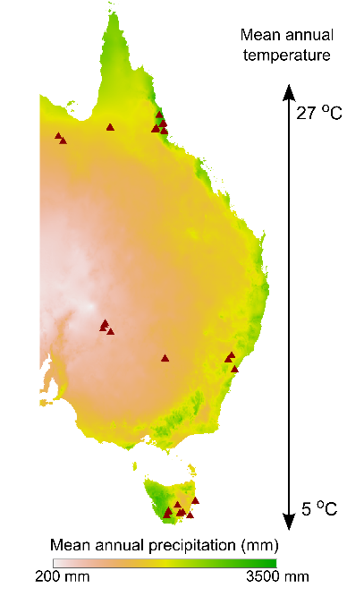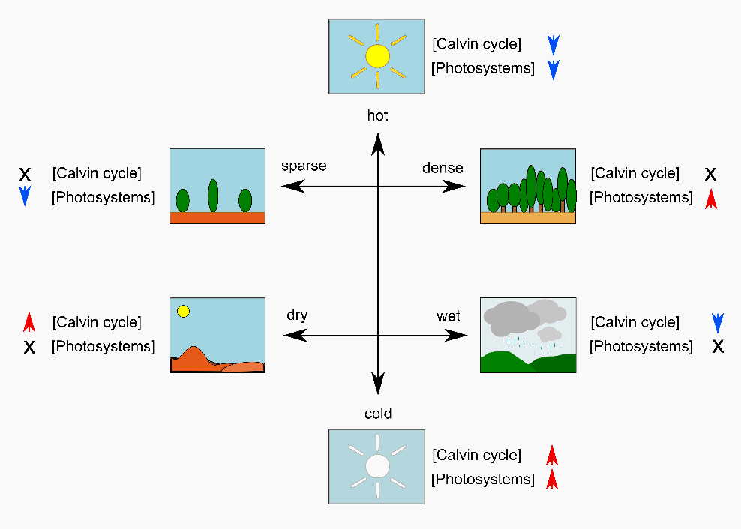

Figure .) (left) Location of sampling sites across eastern Australia. Sites are marked by red triangles; 2.) (right) Hypotheses about differential investment in light capture and carbon assimilation proteins along gradients of temperature, precipitation and light availability (represented here as canopy density). Red up arrows indicate a predicted increase, blue down arrows indicate a predicted decrease, black ‘X’ indicates no predicted trend. The environmental gradients described here can be more or less overlaid across the map in Fig. 1. It is worth noting that although distinct mechanisms underlie hypotheses regarding canopy density and precipitation, the two variables are strongly related. [this caption needs refining, also need to standardise display of units – ‘mean annual precip (mm)’ vs ‘mean annual temperature’]

REFERENCES

Armengaud, J., Trapp, J., Pible, O., Geffard, O., Chaumot, A. & Hartmann, E.M. (2014) Non-model organisms, a species endangered by proteogenomics. *Journal of Proteomics*, **105**, 5–18.

Baer, B. & Millar, A.H. (2016) Proteomics in evolutionary ecology. *Journal of Proteomics*, **135**, 4–11.

Blankenship, R.E. & Hartman, H. (1998) The origin and evolution of oxygenic photosynthesis. *Trends in Biochemical Sciences*, **23**, 94–97.

Chen, J., Reynolds, J.F., Harley, P.C. & Tenhunen, J.D. (2009) Coordination Theory of Leaf Nitrogen Distribution in a Canopy. *Ecology*, **93**, 63–69.

Diz, A.P. & Calvete, J.J. (2016) Ecological proteomics: Is the field ripe for integrating proteomics into evolutionary ecology research? *Journal of Proteomics*, **135**, 1–3.

Ekblom, R. & Galindo, J. (2010) Applications of next generation sequencing in molecular ecology of non-model organisms. *Heredity*, **107**, 1–15.

Farquhar, G.D., von Caemmerer, S. & Berry, J.A. (1980) A biochemical model of photosynthetic CO2 assimilation in leaves of C3 species. *Planta*, **149**, 78–90.

Farquhar, G.D., von Caemmerer S & Berry, J.A. (2001) Models of photosynthesis. *Plant Physiology*, **125**, 42–45.

Haxeltine, A. & Prentice, I.C. (1996) A General Model for the Light-Use Efficiency of Primary Production. *Functional Ecology*, **10**, 551–561.

Hikosaka, K., Ishikawa, K., Borjigidai, A., Muller, O. & Onoda, Y. (2006) Temperature acclimation of photosynthesis: mechanisms involved in the changes in temperature dependence of photosynthetic rate. *Journal of Experimental Botany*, **57**, 291–302.

Maire, V., Martre, P., Kattge, J., Gastal, F., Esser, G., Fontaine, S. & Soussana, J.F. (2012) The coordination of leaf photosynthesis links C and N fluxes in C3 plant species. *PLoS ONE*, **7**, 1–15.

Niinemets, Ü. (2007) Photosynthesis and resource distribution through plant canopies. *Plant, Cell and Environment*, **30**, 1052–1071.

Niinemets, U. & Tenhunen, J.D. (1997) A model separating leaf structural and physiological effects on carbon gain along light gradients for the shade-tolerant species Acer saccharum. *Plant, Cell and Environment*, **20**, 845–866.

Raven, J.A. (2013) Rubisco: Still the most abundant protein of Earth? *New Phytologist*, **198**, 1–3.

Wang, Z., Gerstein, M. & Snyder, M. (2009) RNA-Seq: a revolutionary tool for transcriptomics. *Nature reviews. Genetics*, **10**, 57–63.

Wright, I.J., Reich, P.B., Cornelissen, J.H.C., Falster, D.S., Groom, P.K., Hikosaka, K., Lee, W., Lusk, C.H., Niinemets, Ü., Oleksyn, J., Osada, N., Poorter, H., Warton, D.I. & Westoby, M. (2005) Modulation of leaf economic traits and trait relationships by climate. *Global Ecology and Biogeography*, **14**, 411–421.

Wright, I.J., Reich, P.B., Westoby, M., Ackerly, D.D., Baruch, Z., Bongers, F., Cavender-bares, J., Chapin, T., Cornelissen, J.H.C., Diemer, M., Flexas, J., Garnier, E., Groom, P.K. & Gulias, J. (2004) The worldwide leaf economics spectrum. *Nature*, **428**, 821–827.